Machine Description | Photographer is a web exploitation-centric boot2root machine that demonstrates how improper handling of user-supplied files and CMS misconfigurations can lead to remote access and eventual root compromise.
Target IP | 192.168.0.108
Vulnerability Name | The target machine is vulnerable to Unrestricted File Upload due to improper server-side validation, which leads to Remote Code Execution. Further misconfigurations allow Privilege Escalation, resulting in full system compromise.
Service/Version | TCP 445 / SMB  TCP 8000 / HTTP
CVSS Score and severity | 9.8 Critical
Attack Vector | CVSS:3.1/AV:N/AC:L/PR:N/UI:N/S:U/C:H/I:H/A:H
Proof Of concept | STEP 1- Discover the target machine IP using NetDiscover  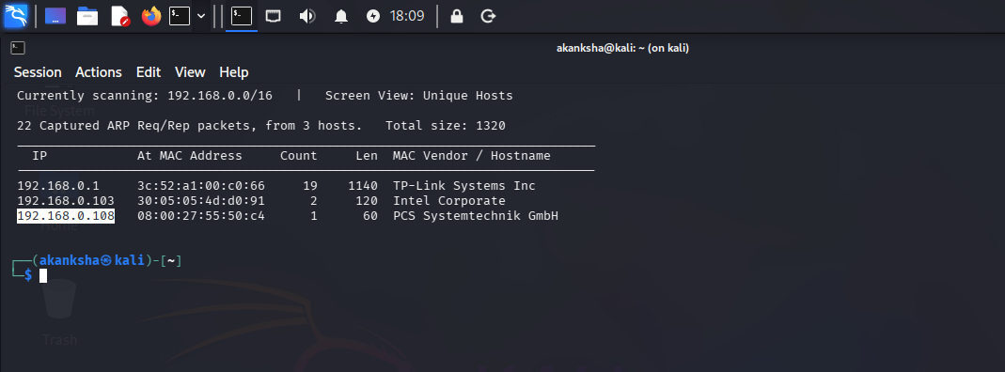  We use Netdiscover Tool for scanning hosts, we found the 192.168.0.108 is our target virtualbox host IP (Photographer machine IP)  STEP 2 - Look for Open ports and Services running on the target system using Nmap  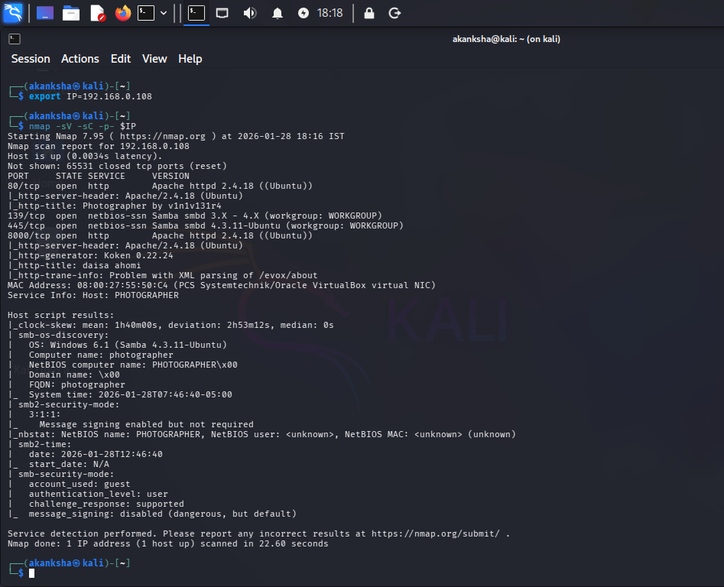  STEP 3 – Let’s Enumerate and gather information about target  - First enumerate via using the browser (In Search bar paste the ip address of machine)  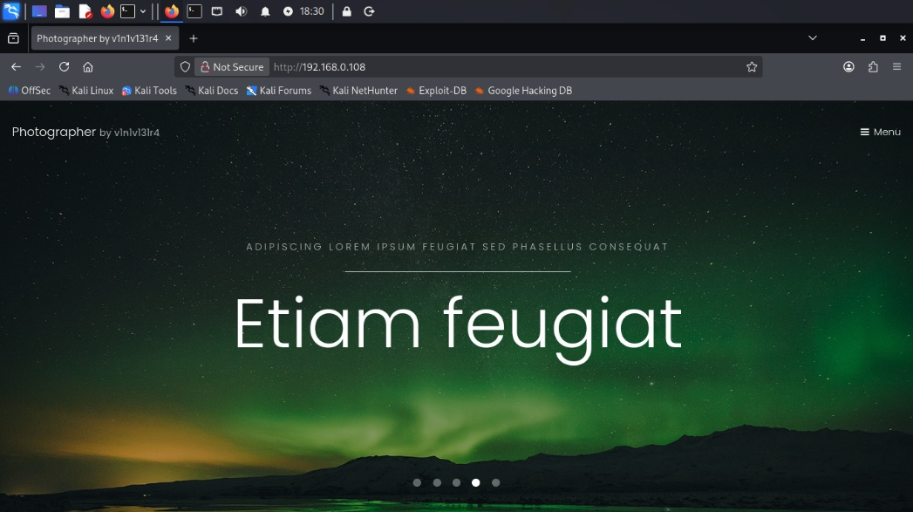  - We found some service SSH, HTTP, FTP, SM  - Lets look for the files on the web server port 80  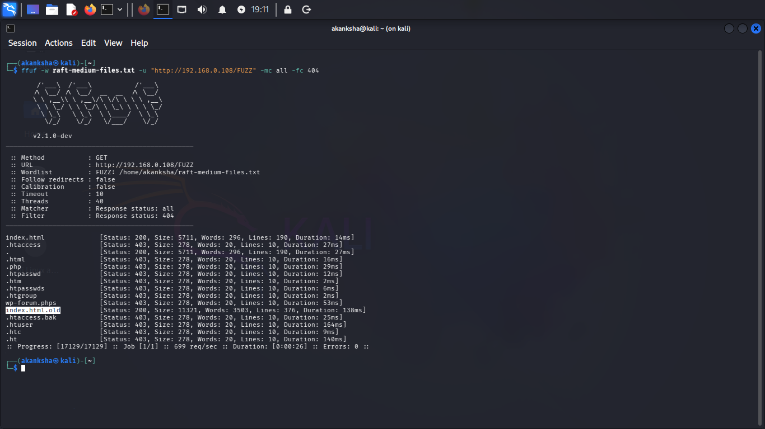  Note: download the raft-medium-files.txt & raft-medium-directories.txt from github  - Let’s now look for the directories on server port 80  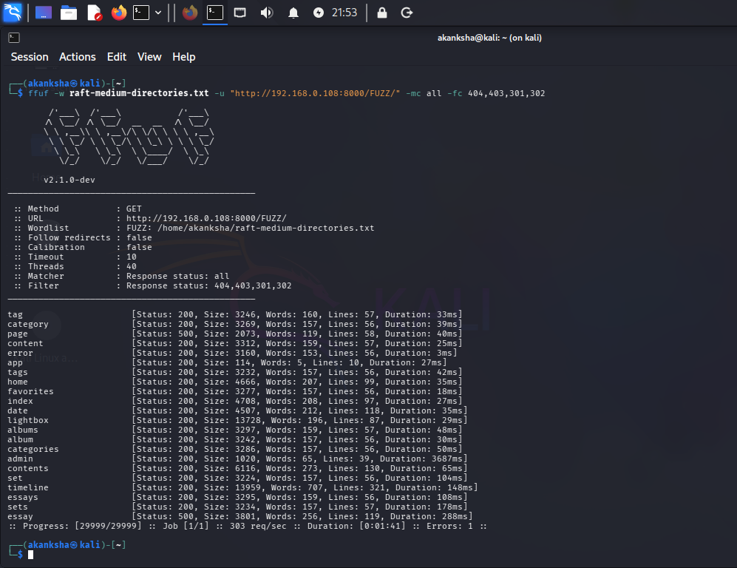  - We have /admin panel on 8000 a CMS login KOKEN  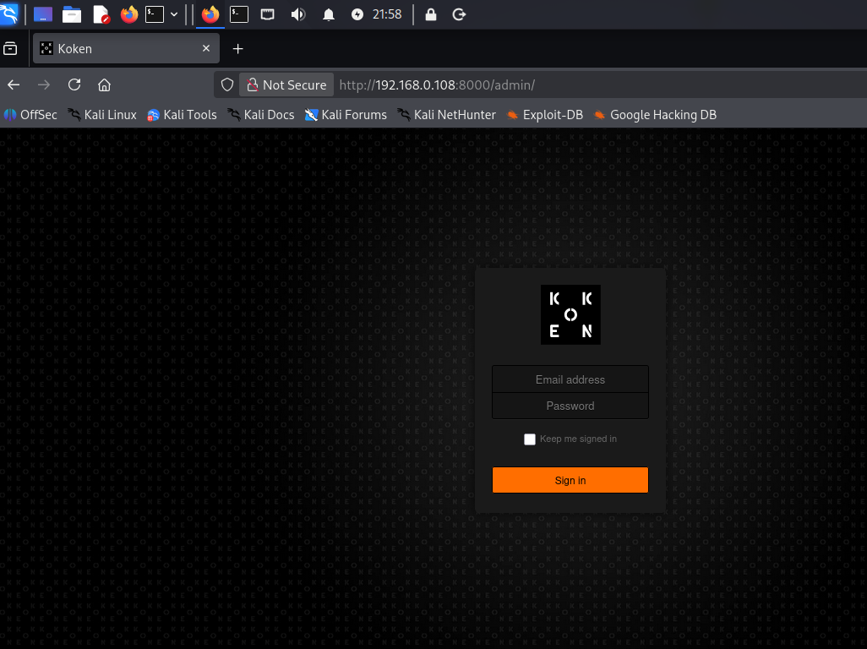  STEP 4 -Let’s Try Enumeration on SMB BY using smbclient  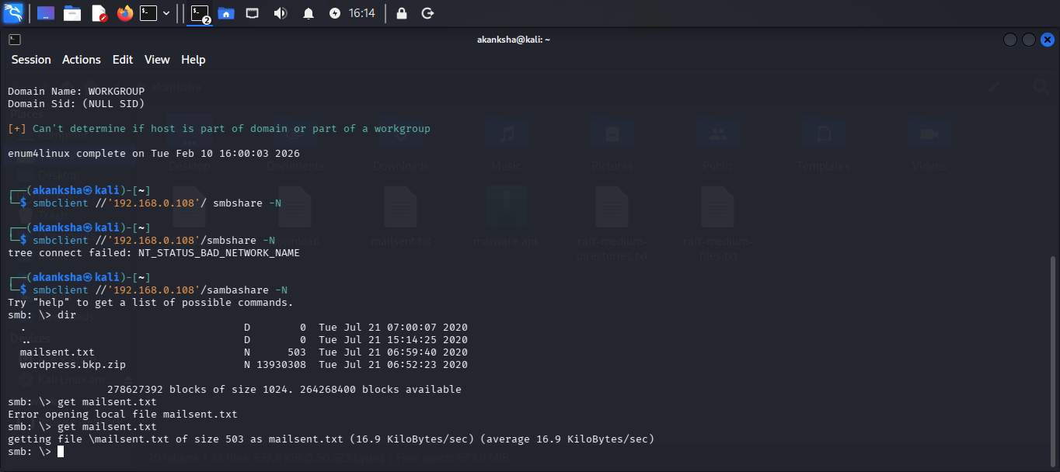  - We got share folder named sambashare  - We also found two files on share server lets enumerate them  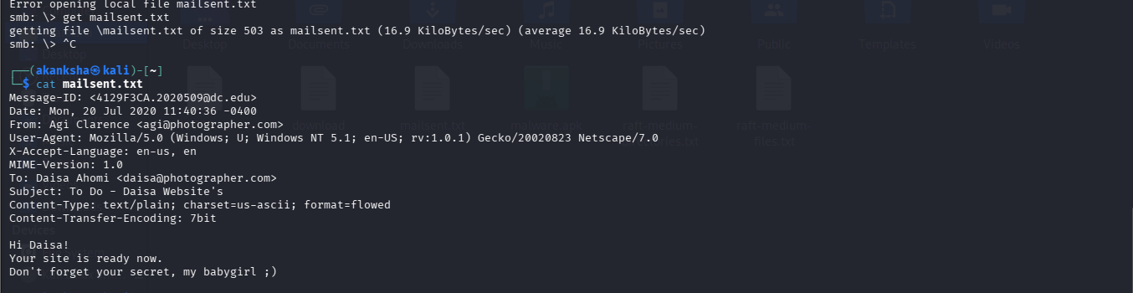  - Valid User 1 Daisa Ahomi daisa@photographer.com  - Valid User 2 Agi Clarence agi@photographer.com  - Secret : babygirl for Daisa  STEP 5 – Try to use these content on CMS  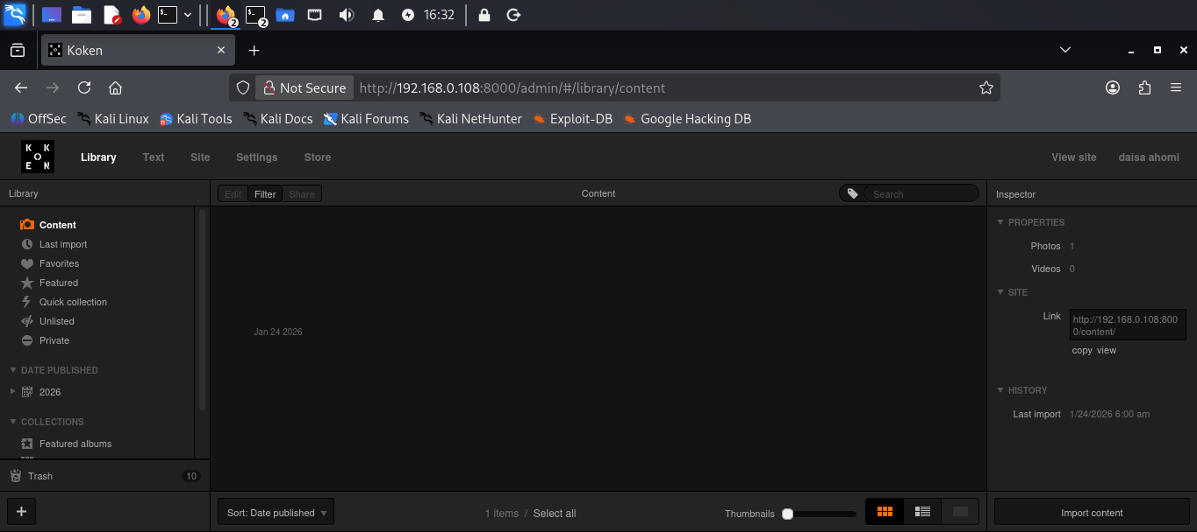  We login successfully.  Let’s look for upload functionality and try to upload because We found about CMS in exploit DB we got file upload relevant things.  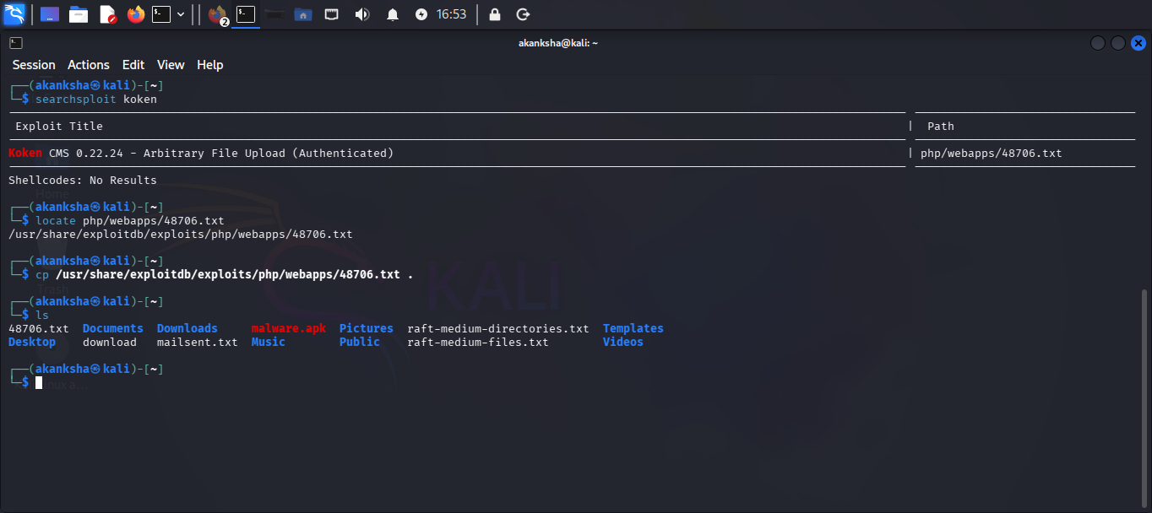  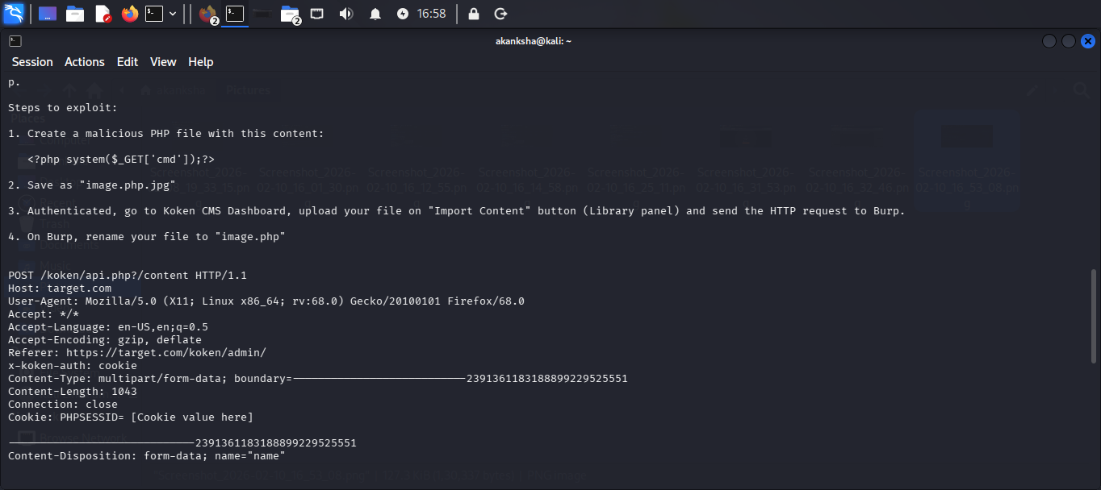  - So lets try out as mention in the exploit first lets create exploit from pentest monkey and save as image.php.jpg  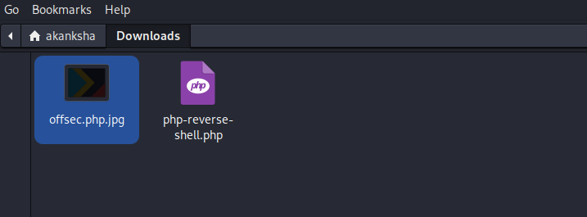  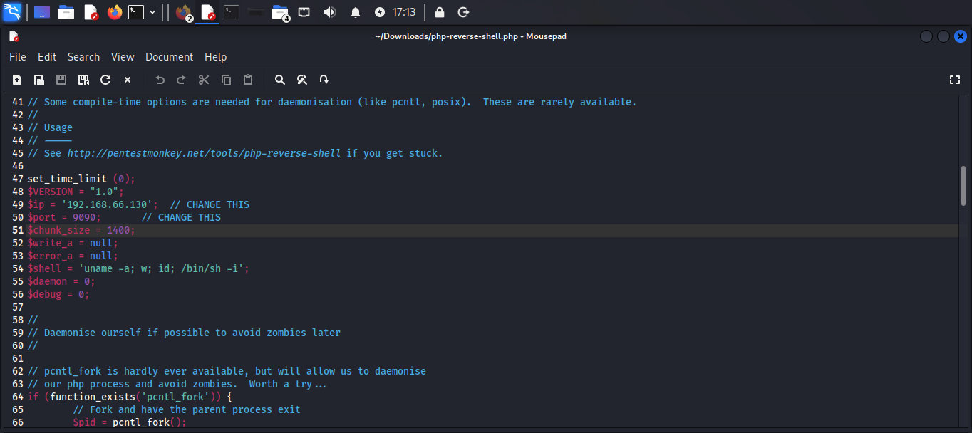  - Open burpsuite an try to upload the file trying to bypass file upload restriction and uploading our shell  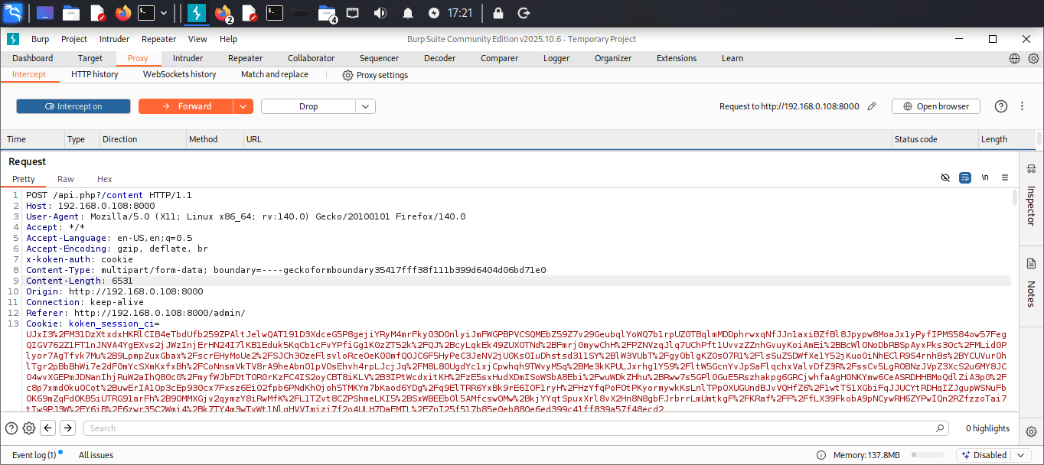  - Setup netcat listener  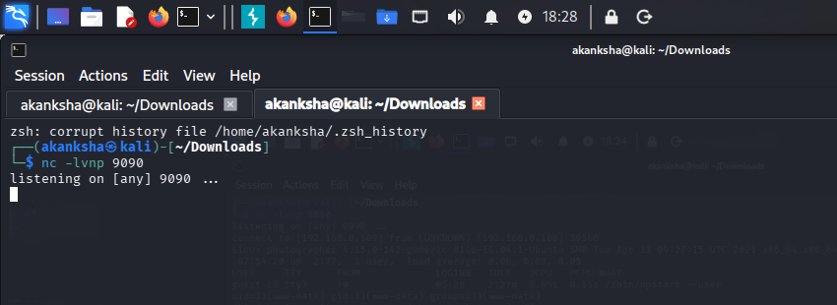  - We will trigger the shell by integrating with options  - We can see we got Shell on target System  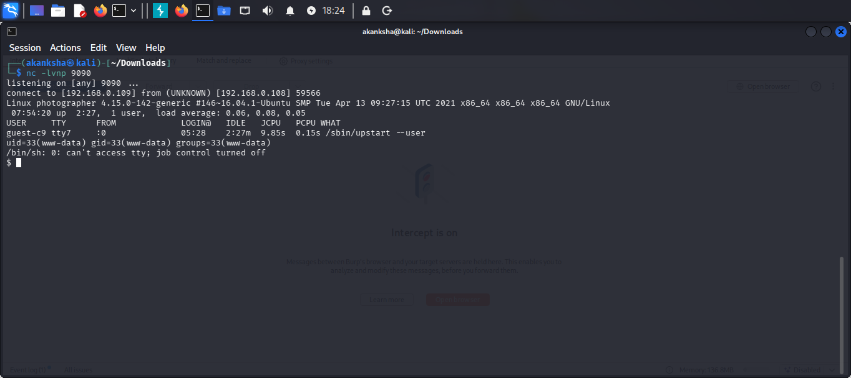  STEP 6 – Now lets look for privilege escalation we have php7.2  We can look for GTFOBiins and try go get root access.  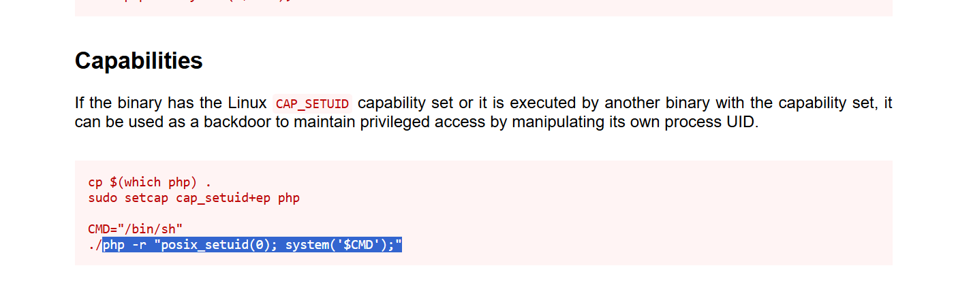  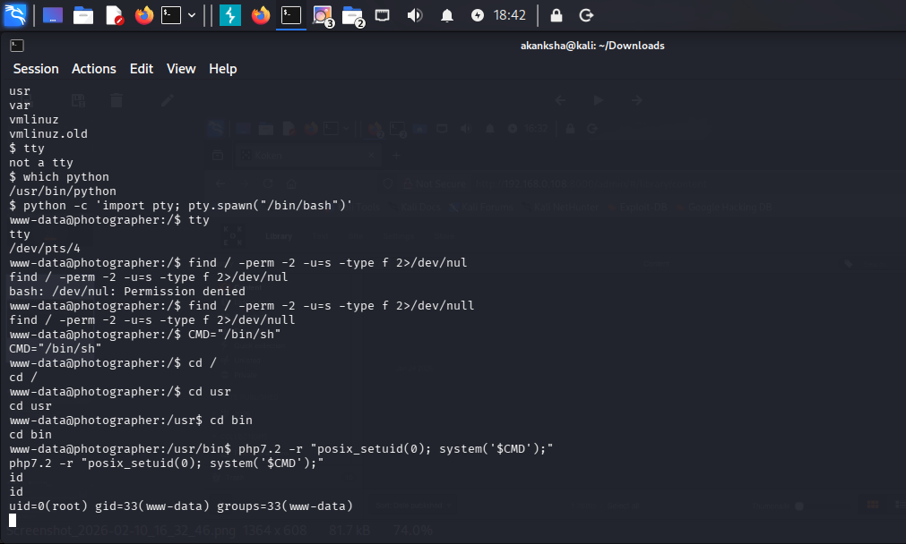
Impact | - Unauthorized access to confidential information.  - Loss of data integrity and service availability  - Complete takeover of the affected server  - Lateral movement within the internal network
Reference | https://www.exploit-db.com/exploits/48706  https://www.exploit-db.com/exploits/48706  https://lifesfun101.github.io/2020/08/09/Photographer-walkthrough.html

